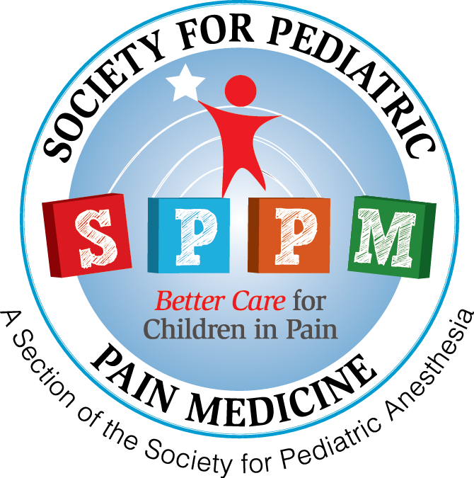
Society for Pediatric Pain Medicine
Young Investigator Research Award
2025
Society for Pediatric Pain Medicine
Young Investigator Research Award

YOUNG INVESTIGATOR RESEARCH AWARD

Up to $ 2,000 is available as a one-time award to Society for Pediatric Pain Medicine Members. The award is designed to encourage young SPPM members to further research in pediatric pain medicine related patient care or for the wellbeing of SPPM members.

Submission deadline: December 15, 2024

Eligibility: Current Members of the Society for Pediatric Pain Medicine who are no more than 7 years from completion of their last formal training.
Award: Awards will be made on the basis of a competitive application process. It is an opportunity for young SPPM members to further research in pediatric pain medicine related patient care or for the wellbeing of SPPM members.

Proposal Submission and Review: Questions regarding the application process and administrative issues should be directed to SPPM office, Ms. Jenny Peterson. Proposals will be evaluated and ranked by the SPPM Research Committee. Selection criteria for the award will include the quality of the project, the extent the opportunity will contribute to the advancement of the health and welfare of pediatric patients or SPPM members. The project must be completed within one year.

Office of Sponsored Programs Proposal Summary and Approval Form
Awardees only will need to submit a Proposal Summary and Approval Form to the Office of Sponsored Programs following notification.

Final Report
We plan to invite the awardee to deliver an oral presentation to the SPPM members during the SPPM Annual Meeting. A final report summarizing accomplishments will be submitted one month prior to the SPPM Annual Meeting. The requirements for the final report will be determined by the Committee and will be based on the proposal.

Society for Pediatric Pain Medicine
Young Investigator Research Award

Application Format
E-mail in PDF to Society for Pediatric Pain Medicine who are no more than 7 years from completion of their last formal training.

Title page: Name, Project title, address, telephone, e-mail, and Chief of Service or Department Chair information (see application checklist) and proposed starting date.

Proposal summary: Summary; background; hypothesis; objectives; preliminary data; methods; analysis; a description plans of the activities under the award; timeframe; and references. Please use the enclosed form (2 page limit, double spaced, size 10 font).

Budget: Specify the total amount (up to $2,000) needed to fund the project and how this will be used. Please use the enclosed budget justification.

Curriculum vitae: Limit of 2 pages in NIH format.

Society for Pediatric Pain Medicine
Young Investigator Research Award

Title Page

Award Application
Applicant Name:
Telephone:
Email:
Chief of the Service or Department Chair:
Project Title:

Eligibility:
Current Member of SPPM

Please review your final application for the following required materials:
Title page
SPPM STAFF USE ONLY
__ Org./2 c & e subm
Title Page
__ a.
__ b.
__ c.
CV __ App
Budget
__ MS __ Just.
Proposal / Summary
__ Complete
Letters
__ a. Chair
IRB
__ Complete __ Explain
Conditions
__ Complete

a. Title of research proposal
b. Applicant’s name, degrees, rank, mailing address, fax numbers, e-mail
c. Chief of the Service or Dept. chair’s name.
2. Proposal Summary
a. Complete, double-spaced size 10 font
3. Budget forms
a. Part 1- Detailed (complete, no unallowable items)
b. Part 2- Justification complete
4. Biographical sketch
a. Applicant’s CV
6. Approval letter from animal or human review committee, if applicable
a. Complete
b. Approval not obtained, letter of explanation included
Society for Pediatric Pain Medicine
Young Investigator Research Award

Proposal Summary
Applicant Name:

Society for Pediatric Pain Medicine
Young Investigator Research Award
Award Application
Applicant Name:

Grant Budget: Part 1- Detailed

The “Other funds” column should be used to list funds that are not provided by SPPM but are required to complete the proposed project. The source(s) for these funds must be detailed in the budget justification.

Society for Pediatric Pain Medicine
Young Investigator Research Award

Award Application
Applicant Name:

Grant Budget: Part 2- Justification
(use additional pages as necessary)

            - Justification of costs and identification of departmental and other funding sources or contributions to the project.

            - Describe facilities, equipment, supplies, and services that are required and available for the completion of this project.

            - Describe briefly other current research projects that involve the applicant and indicate the time commitment and source of funding for each. Indicate the extent of overlap with the present project.

Society for Pediatric Pain Medicine
Young Investigator Research Award

Award Application
Applicant Name:

Acceptance of Conditions

I will acknowledge the support of the Society for Pediatric Pain Medicine Innovative Research Award, if applicable, in all publications resulting from the work during the award period and in all professional correspondence.

I agree to deliver an oral presentation of the project results to the SPPM members during the SPPM meeting. I agree to provide a financial and summary report of the work accomplished during the award period by February 28, 2026.

Applicant:

Signature_____________________________ Date ______________________

Department Chair or Chief of the Service

I agree to provide the support essential to the research activities outlined in this application. Should the recipient fail to complete this study or if other support is obtained for this research, unused funds will be returned to the Society for Pediatric Pain Medicine.

Department Chair or Chief of the Service:

Signature ____________________________ Date ______________________

